A DEVICE USED TO DETECT STOOPNG WITH ARDINO

Tatsunori Minami†, Kensuke Nakagiri†, Daiki Mori‡, and Hideya Aoki‡
†Department of Information Science and Intelligent Technology, Tokushima University
‡Course of Information Engineering, Department of Creative Engineering,
National Institute of Technology, Anan College

ABSTRACT
We study and read a book while sitting. However, it is possible that it strain our bodies. The objective of our project is to make a device used to notify you of poor posture. We have made a “stoop checker”, device with Arduino, acceleration sensor, LED, and buzzer. Fig.1 shows the stoop checker. If you have bad posture with a hunched back, the stoop checker alerts by sounds and lights. Make use of the stoop checker, you will be able to relieve physical fatigue.

1. INTRODUCTION
Today’s our lives become convenience thanks to various systems such as smartphone, personal computer. Good posture is important for us however people are bad posture to use them much time. It is necessary to conscious good posture. Having bad posture for a long time is bad for the health. Therefore, we thought developing the system that stretch spine out.

2. SYSTEM AND STRUCTURE
Firstly, as shown in the Fig.2 the stoop checker put in the basket. The way the stoop checker is used only has it around your neck. Acceleration sensor detects a tilting angle in a vertical direction of the stoop checker. If value of acceleration sensor reaches the threshold of bad posture, red LED switches on, buzzer sounds to warn. And using the basket that has a hook, we can detect the stoop. When this basket is hung with string, the basket is inclined. In addition, if the posture is correct, the basket will be attached your stomach and this means good posture. However, when the posture is

bad, the basket will not be attached your stomach. This difference makes stoop checker enable to detect a stoop

3. CONCLUSION
We have made a “stoop checker” to detect the bad posture by combination of the acceleration sensor and the basket.
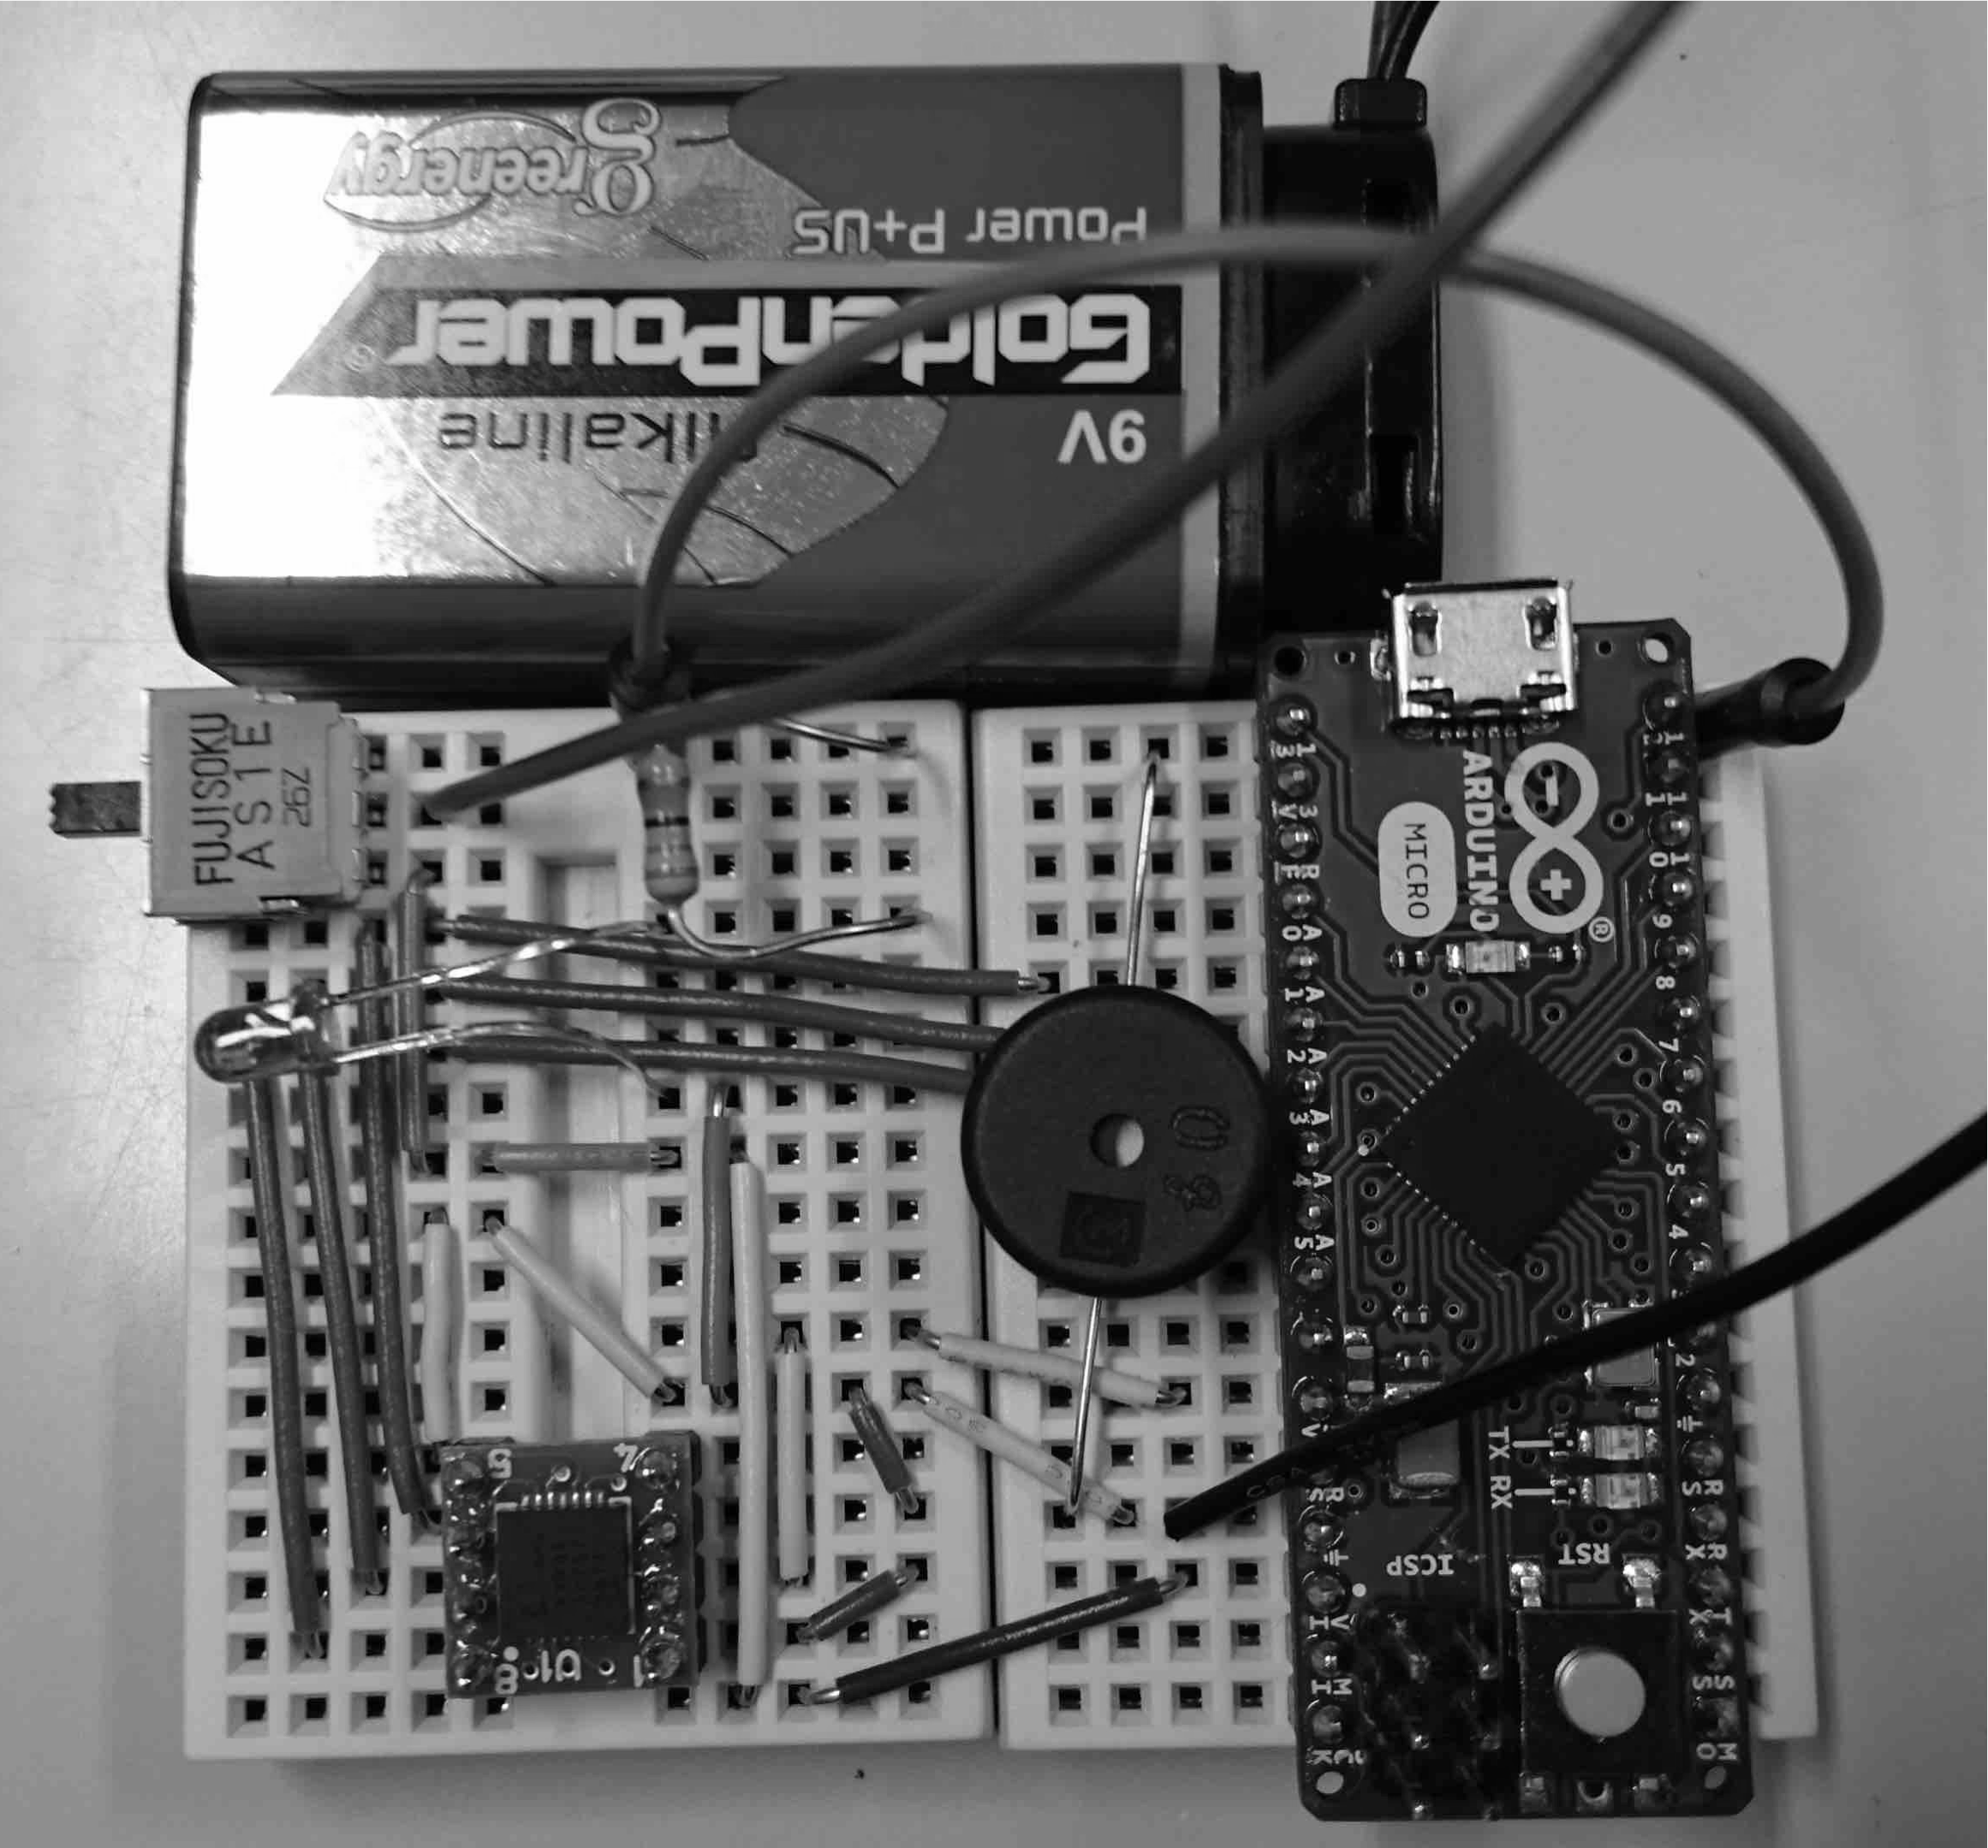

Fig 1: stoop checker

