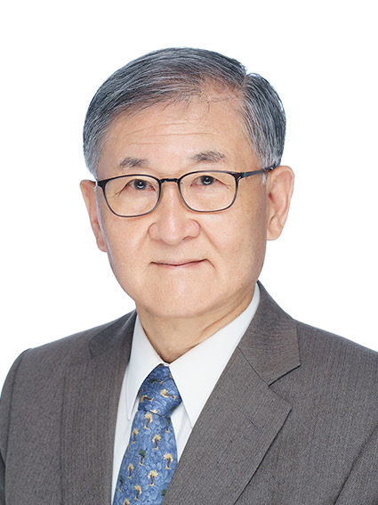
Sung-Mo “Steve” Kang
Distinguished Professor Emeritus and Research Professor, UC Santa Cruz
Chancellor Emeritus, UC Merced; President Emeritus, KAIST
Sung-Mo “Steve” Kang is a Distinguished Professor Emeritus and Research Professor of the Baskin School of Engineering, UC Santa Cruz, Chancellor Emeritus of UC Merced, and President Emeritus of KAIST. He has published over 500 journal and conference papers, 10 books, and holds 17 patents. In September 2025, his work had been cited 22,000 times with an h-index of 60, according to Google Scholar. He has received numerous best paper awards from IEEE journals and conferences. He was named a 2024 top scholar by ScholarGPS.
Before returning to academia in 1985, he led the development of the world’s first fully 32-bit CMOS microprocessor, BELLMAC-32, chipsets for telecommunication and computing applications as a technical supervisor at AT&T Bell Laboratories in Murray Hill, New Jersey. This development was recognized as an IEEE Milestone in February 2025. He has received honors, including the Silicon Valley Engineering Hall of Fame induction, the Alexander von Humboldt Senior US Scientists Award, the inaugural Korean Academy of Science and Technology (KAST) Deok Myeong Engineering Award, the KBS Award in industrial technology, the IEEE Millennium Medal, the IEEE Mac Van Valkenburg Circuits and Systems (CAS) Society Award, the IEEE CAS Society Technical Excellence Award, the US Semiconductor Research Corporation (SRC) Technical Excellence Award, the IEEE Leon K. Kirchmayer Graduate Teaching Technical Field Award, the IEEE CAS Society John Choma, Jr. Education Award, the Chang-Lin Tien Education Leadership Award, and distinguished alumni awards from UC Berkeley, The University at Buffalo, Fairleigh Dickinson University, and Yonsei University.
Dr. Kang is a Life Fellow of the IEEE, a Fellow of the Association for Computing Machinery (ACM), the American Association for the Advancement of Science (AAAS), and the Asia-Pacific AI Association (AAIA). He is a life member of the Korean Academy of Science and Technology (KAST) and a foreign member of the National Academy of Engineering, Korea (NAEK), a member of the European Academy of Sciences and Arts (EASA), and the National Academy of AI (NAAI). He has served as President of the IEEE Circuits and Systems Society and the Silicon Valley Engineering Council, as General Chair of the IEEE ISCAS conferences, and as Founding Editor-in-Chief of the IEEE Transactions on VLSI Systems. He received his B.S. degree (Summa Cum Laude) from Fairleigh Dickinson University, Teaneck, New Jersey, in 1970, an honorary B.S degree from Yonsei University, an M.S. degree from the State University of New York at Buffalo in 1972, and a Ph.D. degree from the University of California at Berkeley in 1975, all in electrical engineering. His research interests include nonlinear circuits and systems, compact modeling of novel devices, computer-aided design of low-power high-performance CMOS and optoelectronic circuits, design for reliability and manufacturability, memristors and memristive systems, and their applications to neuromorphic computing for AI.

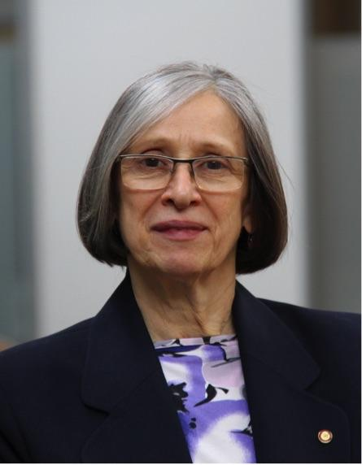
Ljiljana Trajkovic
Professor, School of Engineering Science, Simon Fraser University, Canada
Ljiljana Trajkovic received the Dipl. Ing. degree from University of Pristina, Yugoslavia, in 1974, the M.Sc. degrees in electrical engineering and computer engineering from Syracuse University, Syracuse, NY, in 1979 and 1981, respectively, and the Ph.D. degree in electrical engineering from University of California at Los Angeles, in 1986.
She is currently a Professor in the School of Engineering Science at Simon Fraser University, Burnaby, British Columbia, Canada. From 1995 to 1997, she was a National Science Foundation (NSF) Visiting Professor in the Electrical Engineering and Computer Sciences Department, University of California, Berkeley. She was a Research Scientist at Bell Communications Research, Morristown, NJ, from 1990 to 1997, and a Member of the Technical Staff at AT&T Bell Laboratories, Murray Hill, NJ, from 1988 to 1990. Her research interests include communication networks, computer-aided circuit analysis and design, and nonlinear circuits and dynamical systems.
Dr. Trajkovic served as IEEE Division X Delegate/Director (2019–2020) and IEEE Division X Delegate-Elect/Director-Elect (2018). She served as Senior Past President (2018–2019), Junior Past President (2016–2017), President (2014–2015), President-Elect (2013), Vice President Publications (2012–2013, 2010–2011), Vice President Long-Range Planning and Finance (2008–2009), and a Member at Large of the Board of Governors (2004–2006) of the IEEE Systems, Man, and Cybernetics Society. She served as 2007 President and 2006 President-Elect of the IEEE Circuits and Systems Society and a member of its Board of Governors (2004–2005, 2001–2003). She served as Chair of the IEEE Circuits and Systems Society joint Chapter of the Vancouver/Victoria Sections (2001–2021). She was Chair of the IEEE Technical Committee on Nonlinear Circuits and Systems (1998). She is General Co-Chair of SMC 2026 and General Co-Chair of SMC Workshops on BMI Systems (2018–2025). She was General Co-Chair of SMC 2020, SMC 2016, and HPSR 2014, Special Sessions Co-Chair of SMC 2017, Technical Program Chair of SMC Workshops on BMI Systems (2016–2017), Technical Program Co-Chair of ISCAS 2005, and Technical Program Chair and Vice General Co-Chair of ISCAS 2004. She serves as Editor-in-Chief of the IEEE Transactions on Human-Machine Systems (2021–2026) and as Associate Editor-in-Chief of the IEEE Open Journal of Systems Engineering (2022–2025). She served as an Associate Editor of the IEEE Transactions on Circuits and Systems (Part I) (2004–2005, 1993–1995), the IEEE Transactions on Circuits and Systems (Part II) (2018, 2002–2003, 1999–2001), and the IEEE Circuits and Systems Magazine (2001–2003). She is a Distinguished Lecturer of the IEEE Systems, Man, and Cybernetics Society (2025, 2020–2021) and was a Distinguished Lecturer of the IEEE Circuits and System Society (2021–2022, 2010–2011, 2002–2003). She is a Professional Member of IEEE-HKN and a Life Fellow of the IEEE.

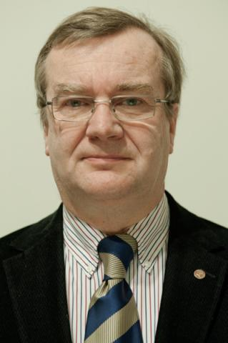
Maciej J. Ogorzalek
Professor and Head, Department of Information Technologies, Jagiellonian University, Poland
Maciej J. Ogorzalek is Professor of Electrical Engineering and Computer Science and Head of the Department of Information Technologies, Jagiellonian University Krakow, Poland – the oldest (1364) higher education institution in the country. He held several visiting positions in Denmark, Switzerland, Germany, Spain, Japan, Hong Kong. He received a Research Award from the Ministry of Education of Spain in 2000 and worked for one year at the National Microelectronic Center, Sevilla, Spain. In 2001 he received a Senior Award from the Japan Society for Promotion of Science as visiting professor at Kyoto University and in 2005 Hertie Foundation Fellowship at the Goethe University Frankfurt am Main. 2006 to 2009 he held the Chair of Biosignals and Systems, Hong Kong Polytechnic University under the Distinguished Scholars Scheme.
He is Author or co-author of over 350 technical papers published in journals and conference proceedings, author of the book Chaos and Complexity in Nonlinear Electronic Circuits (World Scientific, 1997). He gave over 40 plenary and keynote lectures at major conferences world-wide. He served as Editor-in-Chief of the Circuits and Systems Magazine 2004-2007, Associate Editor for the IEEE Transactions on Circuits and Systems Part I, 1993-1995 and 1999-2001, he was elected Member of the Editorial Board Proceedings of the IEEE 2004-2009. He serves also as an Associate Editor – Journal of the Franklin Institute (1997-), Member of the Editorial Board of the International Journal of Bifurcation and Chaos, Secretary of the Editorial Board for the Quarterly of Electrical Engineering (1993-2000), Member of the Editorial Board of Automatics (both in Polish), and Member of the Editorial board of the International Journal of Circuit Theory and Applications (2000- ) and Associate Editr of the NOLTA Journal IEICE Japan. Dr. Ogorzalek is IEEE Fellow (1997). He served the IEEE Circuits and Systems Society in various capacities including VP fpr Region 8, Administrative Vice-president and finally 2008 Society President. He was CAS Society Distinguished Lecturer(2004-2005) and received the 2002 Guillemin-Cauer Award, IEEE-CAS Golden Jubilee Award and IEEE CAS Meritorious Service Award. Currently he serves as IEEE Division 1 Director (2016-2017, Member of the IEEE Board of Directors. Until 2006 he was Executive Vice-President of the Sniadecki Science Foundation in Poland. He is Member of the Polish Academy of Sciences (PAN) and Member of the European Academy of Sciences (Academia Europaea).

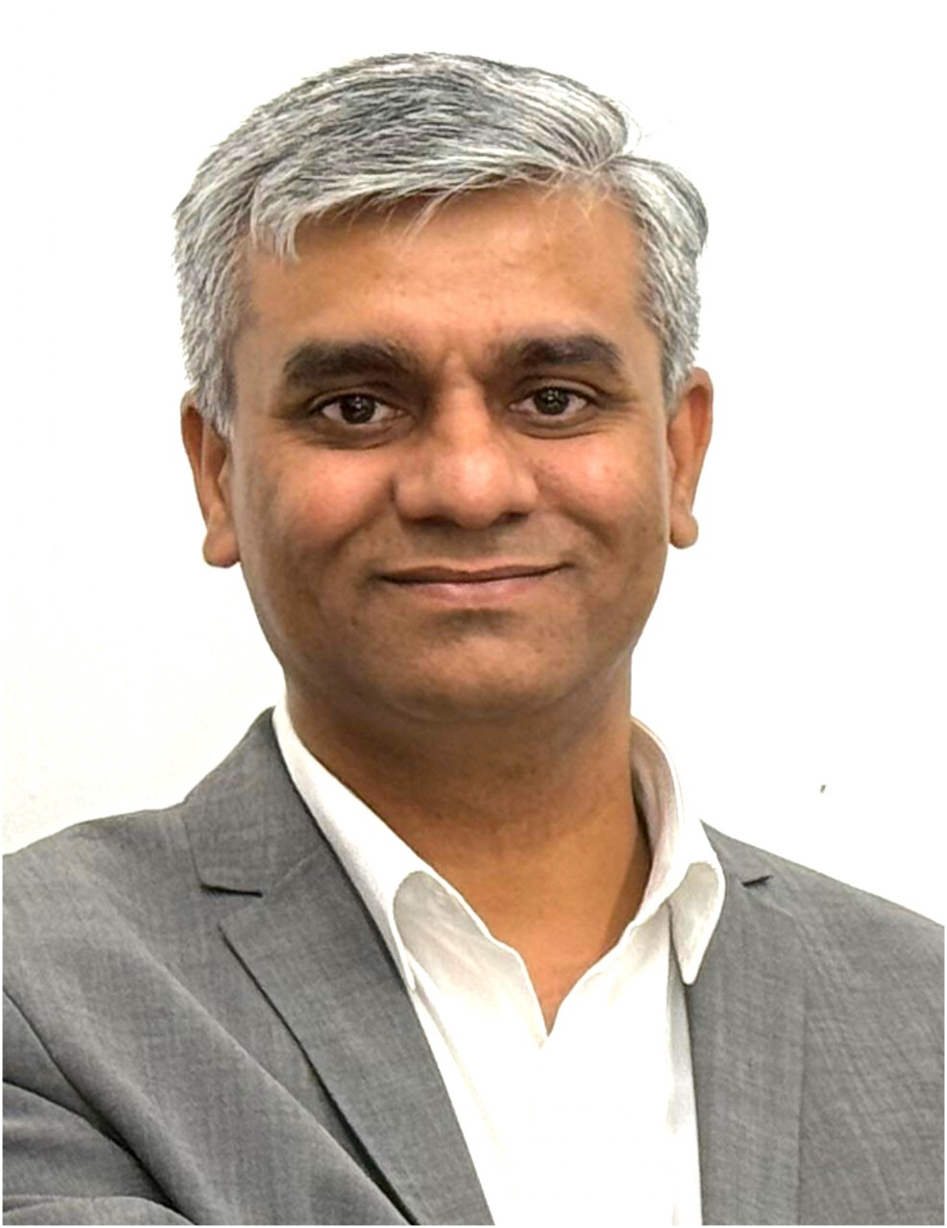
Preet Yadav
Chair, IEEE CASS Delhi Joint Chapter
Yadav Preet is Chairperson of IEEE Circuit and Systems Society (CASS), Delhi Chapter. He is Head India Innovation Ecosystem at NXP Semiconductors. Prior to re-joining NXP in his second stint, he was working with Wipro as Analog Practice Head, Distinguished Member of Technical Staff (DMTS) - Wipro Senior Member, leading Analog & Mixed Signal Practice globally in VLSI Technology Group.
He has more than two decades of enriched Research & Development experience in the diversified Semiconductor industry. His expertise includes Analog and Mixed Signal (AMS) design & verification, core technology development of Process Design Kits (PDK) and Electronic Design Automation (EDA). He received B. Tech. degree in ECE from Kurukshetra University and M. Tech. degree in VLSI Design & CAD from Thapar Institute of Engineering & Technology.
During his first stint at Freescale/NXP Semiconductor, he worked on development of Process Design Kits, leading handful of technologies from matured to advance nodes. Further, he worked on Analog and Mixed Signal SOC Verification in Automotive Microcontrollers and Processors R & D at NXP.
He is Faculty Fellow at Technology Innovation Hub – DivyaSampark at Indian Institute of Technology Roorkee. He is Adjunct Faculty (Professor) at ABV-IIITM Gwalior. He is Chair-Elect/Secretary of IEEE CASS - VLSI Systems & Applications Technical Committee (VSATC). He is member of IEEE CASS Standards Committees (SASD), IEEE CASS Industry Engagement Committees, and IEEE CASS Digital Communication Committees. He is Associate Editor of IEEE Sensors Alert. He is senior member of IEEE Solid-State Circuits Society (SSCS) & IEEE Standards Association (SA). He is member of Board of Studies for reputed institutes. He received President Award in Scouts & Guides and accoladed with various awards of merit throughout his academics and industrial endeavor. He has multiple publications in international IEEE conferences, with three best paper awards on his name.
He is the youngest Fellow Member of Indian Society of Systems for Science and Engineering (ISSE), Fellow Member of The Institution of Electronics Telecommunication Engineers (IETE), Senior Member of Institute of Electrical and Electronics Engineers (IEEE). He is member of VLSI society of India (VSI) and is core team member of VLSI Design (VLSID) Conference Steering Committee. He is actively associated with multiple community relations groups.
www.linkedin.com/in/preet-yadav

